# Kanban – Tasks by Status

The prebuilt *Kanban – Tasks by Status* provides quick overview of registered tasks in your NetSuite account, with each Kanban column representing a task status. The column *Completed* will only show task completed within this week.

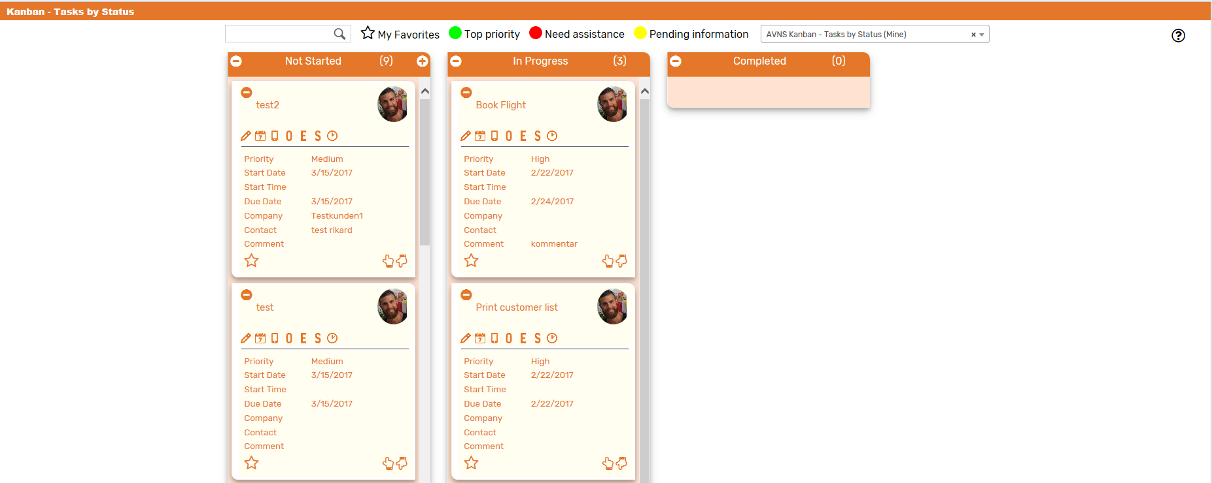

### Kanban – Tasks by Status: Prerequisites

Before using the *Kanban – Tasks by Status*, please make sure the prerequisites listed below are fulfilled in order for the board to function as expected.

1. **Sales Rep & Sales Rep Image**  
   Make sure to mark the checkbox ‘Sales Rep’ on the Employee record for all available Sales Reps.
2. If an image has been uploaded to the *Image* field on the Employee record, this image will be displayed on the Kanban card. If no image is available, a predefined profile icon will be displayed instead.

### 

### Kanban – Tasks by Status: Card Moves & Column Actions

The *Kanban – Tasks by Status* board contains three Kanban Columns. Each column has been configured with one Column Action. Double clicking on any card in the *Kanban – Tasks by Status* board will open the task record in edit mode.



1. **Not Started**
   1. *Card Moves* – Kanban cards in the column *Not Started* can be moved to all other columns in the Kanban board.
   2. *Column Actions* – When moving a Kanban card to the column *Not Started* the status of the record represented in the Kanban card will be updated to *Not Started.*

1. **In Progress**
   1. *Card Moves* – Kanban cards in the column *Not Started* can be moved to all other columns in the Kanban board.
   2. *Column Actions* – When moving a Kanban card to the column *In Progress* the status of the record represented in the Kanban card will be updated to *In Progress*.
2. **Completed**
   1. *Card Moves* – Kanban cards in the column *Completed* can be moved to all other columns in the Kanban board.
   2. *Column Actions* – when moving a Kanban card to the column *Completed* the status of the record represented in the Kanban card will be updated to *Completed.*

### Kanban – Tasks by Status: Available Card Actions

The Kanban cards in the *Kanban – Tasks by Priority* board each contains seven Card Actions.

1. 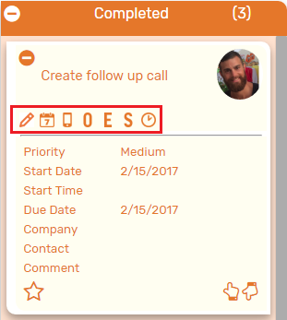**TASK: New Note**Add a new note to the task from the Kanban card.
2. **TASK: New Event**Create a new event from the Kanban card.
3. **TASK: New Phone Call**Create a new phone call from the Kanban card.
4. **TASK: New Opportunity**Create a new opportunity from the Kanban card.
5. **TASK: New Estimate**Create a new estimate from the Kanban card.
6. **TASK: New Sales Order**Create a new sales order from the Kanban card.
7. **TASK: Enter Time**Add a time tracking record to the task from the Kanban card.

### Kanban – Tasks by Status: Alternative Searches

There are two alternative searches for the *Kanban – Tasks by Status* board.  
  
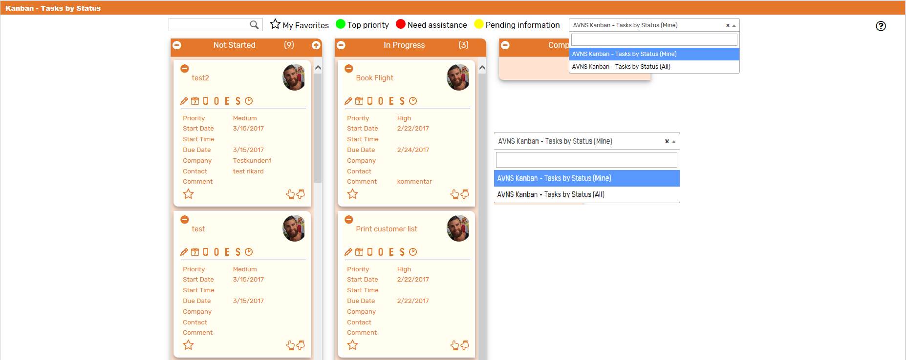

1. **AVNS Kanban – Tasks by Status (All)**This search will display all registered tasks in the *Kanban – Tasks by Status* board.
2. **AVNS Kanban – Tasks by Status (Mine)**This search will display registered tasks where assigned to is *Mine* (current user) in the *Kanban – Tasks by Status* board.

### Kanban – Tasks by Status: Available Colors

There are three colors available for the *Kanban – Tasks by Status* board, which can be used to highlight and filter the Kanban cards (*Top priority // Pending information // Need assistance*). These are defined in the *Color* subtab of the Kanban configuration record.

